Method 1:-

Steps

1. Your data should in different different sheet in a worksheet
2. You can only combine same number of columns but you can take any number of rows
3. Press alt + D + P
4. 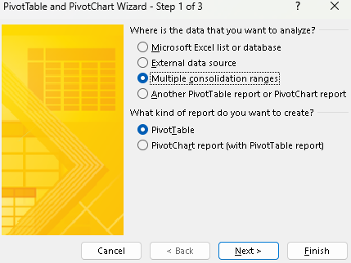
5. 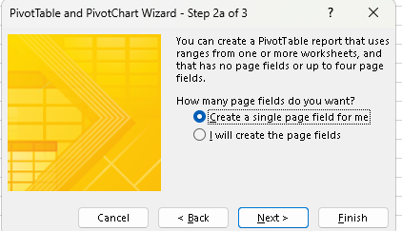
6. Create a single page field for me is a method 1 .. in this only pivot table will be formed with combined data
7. 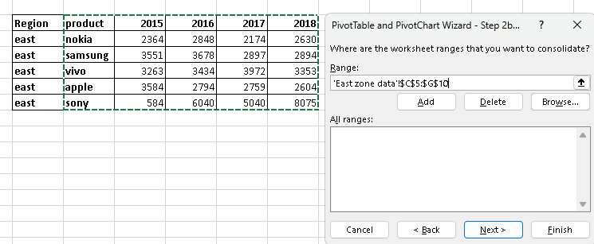
8. Select data like this and Press ADD all the tables will be added to this zone then press finish
9. Select other sheet for pivot table making

Method 2:-

Steps

1 ) Select the I will create the page then select atleast one field … you can rename all the sheet name

Here , where field one is written … just click on the added data and give names to one by one

2 ) then press finish and select other sheet to plot pivot table ….

Now if you want to see all the combined data just remove the fields from pivot table fields except values and when you double click on sum of values all the combined data will be shows to one sheet

